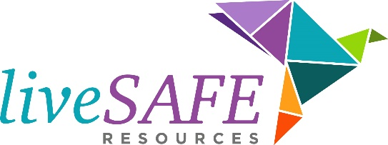
In-Kind Donation Wish List
(Updated May 2019)

Please call 770-427-2902 to make an appointment to drop off donations at our administrative office at 48 Henderson St. Marietta, GA. 30064. Unfortunately, due to our constantly changing needs and limited storage space. We appreciate a call before drop off if possible.

Shelter
Toothpaste
Deodorant
Soap & body wash
Bath rugs (new)
Shower curtains (new)
Twin sheets and pillow cases (new)
Twin blankets (new)
Bath towels (new)
Wash cloths (new)
Standard pillows (new)
Diapers and pull-ups (all sizes, but larger sizes are especially needed)
Baby wipes
Feminine hygiene products
Gas and grocery store gift cards

Housing Programs
Queen size mattress covers (new)
Pots & pans
Dishes
Towels and wash cloths (new)
Drinking Glasses
Children’s plates and cups
Queen size bedding (new)
Twin size bedding (new)
Kitchen utensils
Silverware
Kitchen dish towels & potholders
Shower hooks & shower curtains
Laundry detergent PODS ( No Liquid)
Cleaning supplies (mop/bucket, broom/dustpan, etc.)
Trash cans & bags

Sexual Assault
Comfortable clothing such as t-shirts, shorts, sweatpants, sweatshirts, and leggings (new)
Heavy-duty black duffle bags (2)
Panties (new)
Bras (new)
Socks (new)
Flip flops (new)
Individually packaged snacks
Keurig K-cups and coffee supplies (disposable cups, stirrers, sugar, creamer)
Bottled water and soda cans
Toiletry items (Chap Stick, hair ties, toothpaste, Vaseline, lotion, feminine hygiene products)
Laundry supplies (detergent PODs, bleach, fabric softeners)
Medical supplies (Band-Aids, first aid ointment, hydrogen peroxide)
White bath towels (new)
AED machine
Glucometer

Latino Outreach
Grocery store gift cards

Child Advocacy
Baby clothing (new or gently used)
Bottles and sippy cups
Baby towels, wash cloths and blankets (new)
Baby bath wash and lotion
Toddler clothing (new or gently used)
Boys and girls junior size clothing (new or gently used)
Boys and girls under garments (new)
Boys and girls socks and shoes (new)

Legal Advocacy
Kleenex/tissue
Bottled water
Individually packaged snacks
Printer/copy paper
Blue ink pens

Counseling
Journals
Legal Pads
Art Supplies (small canvases, paints, glue sticks, mod podge, markers, oil pastels, colored pencils)
Coloring books for adults
Stress balls
Kinetic Sand
Tea
Essential Oils (especially lavender, lemongrass, sweet orange, chamomile)
Affirmation cards
Any kind of small inspirational gift (bracelets with words, finger labyrinths, etc.)
Kleenex/tissue
Bottled water
Individually packaged snacks

Administration & Development
Bottled water
Candy (lollipops, tootsie rolls, etc.)
Black and blue ink pens
Post-it notes (large and small)
Lysol spray
Hand sanitizer
Clorox wipes
Gallon-sized zip lock bags
Paper towels
Printer/copy paper
Manila folders
.5” and 1” 3-ring binders
Medium roast coffee
Keurig K-cups and coffee supplies (disposable cups, stirrers, sugar, creamer)
Disposable plates, silverware, and cups
Postage stamps
$10 gift cards (Starbucks, Subway, Target, Walmart)

