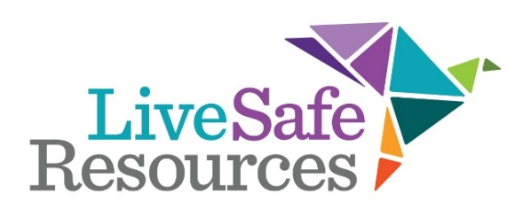

Tribute to Achievement Gala
Friday, March 25, 2022

For more than 20 years, LiveSafe Resources has honored women (and men) for extraordinary achievement in promoting the success of women through this signature community event. The 2022 Tribute to Achievement will recognize stellar leaders in our community who have set the bar for others in their achievements, contributions, and success.

Title Sponsor - $15,000
Prime, reserved seating – Three tables of 8 (24 guests)
Acknowledgement on the invitation and Sponsor’s Remarks from podium
Event naming opportunities
VIP Reception
Prominent logo on event signage and screen projection
Social media recognition leading up to event
Recognition in the event program and on auction app
Sponsorship recognition in the LiveSafe Resources Annual Report, website & press releases

Gold Sponsor - $10,000
Prime, reserved seating – Two tables of 8 (16 guests)
Acknowledgement on the invitation and special recognition from the podium
Limited event naming opportunities (after title sponsor)
VIP Reception
Logo included on event signage and screen projection
Social media recognition leading up to event
Recognition in the event program and on auction app
Sponsorship recognition in the LiveSafe Resources Annual Report, website & press releases

Silver Sponsor - $6,000
Prime, reserved seating – One table for 8 guests
Acknowledgement on the invitation and special recognition from the podium
Logo included on event signage and screen projection
VIP Reception
Social media recognition leading up to event
Recognition in the event program and on auction app
Sponsorship recognition in the LiveSafe Resources Annual Report, website & press releases

Bronze Sponsor - $3,500
Reserved table seating for 8 guests
Logo included on event signage and screen projection
Social media recognition leading up to event
Recognition in the event program and auction app
Sponsorship recognition in the LiveSafe Resources Annual Report, website & press releases

Table Sponsor - $2,000
Reserved table seating for 8 guests
Recognition in the event program and LiveSafe Resources Annual Report

Silent Supporter - $1,000
No-show supporter. We appreciate your support from home!

Patron - $500
Reserved seats for 2 guests plus event program recognition

Tribute to Achievement Gala
Friday, March 25, 2022

Yes! I will support Tribute.

Check: Please make out the check to “LiveSafe Resources”
Mail to:
Attn: Cindy Fennel
48 Henderson Street
Marietta, GA 30064

Pay by credit card online: Go Here to pay online, can also be accessed on the Tribute event page.

