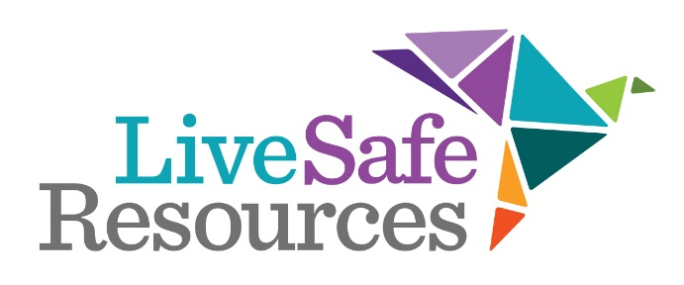
Critical Needs Wish List
Please call 770-427-2902 to make an appointment to drop off donations at our administrative office at 48 Henderson St. Marietta, GA. 30064. Unfortunately, due to our constantly changing needs and limited storage space we cannot accept donations without advance notification.

Gift cards (Gas cards, Visa gift cards, Wal-Mart, Target, Publix, Kroger, etc.)
Bedding for shelter clients (pillows, blankets, sheet sets for twin size beds)
Pull-Ups for toddlers (boys and girls)
Baby Wipes
Shower curtains & rings
Pots, pans, kitchen utensils, dishes, silverware, glassware
Cleaning supplies for Household and Laundry (Windex, PineSol, toilet cleaners and supplies, laundry detergent pods, stain removers, fabric softener, etc.)
Children’s and adult over-the-counter meds (Tylenol, Advil, Dayquil, Motrin, Band Aids, etc.)
Microwaveable soups and mac & cheese cups
Granola or protein bars
Coffee K-cups

Due to space issues, we do NOT accept adult clothing unless it is new and agreed to in advance for a specific purpose. We can refer you to our partner organizations who would be happy to take them!

